**How to use Qualtrics to create a survey?**

**Written by Ray**

(*Note: this instruction is only applicable to students or faculty who hold a Duke Net ID; for those who from other institutions, the process is similar --- which means this instruction is also applicable for non-duke users after making some adjustments.)

1. Access to Qualtrics

Search “duke qualtrics ” on Google, and you’ll find the link to the page where you can access to the Qualtrics.

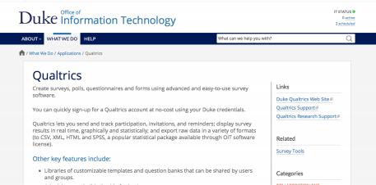

Scroll down to the yellow bar of “ACCESS QUALTRICS” and click on it.

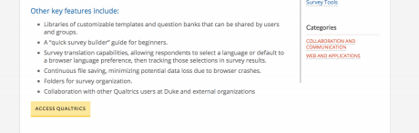

2. Initiate a Survey

Input your NetID and password so that you will be transferring to the Qualtrics page.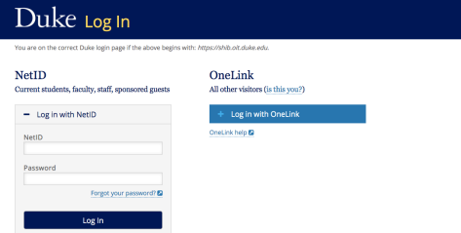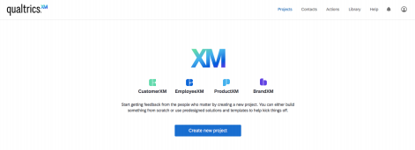

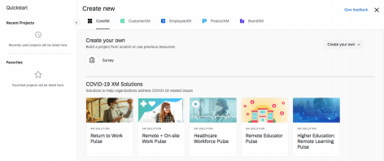Type your project name in the bar highlighted in blue, and then click on “Get Started”. 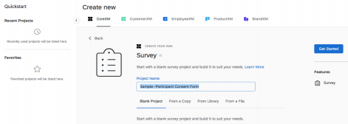

3. Edit Your Survey

You can type text in the blue box, or add sections on the right part (as shown in green).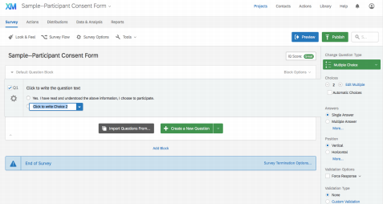

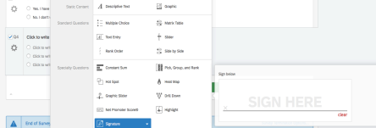

Click on “Preview” to have a preview before generating the link, in case you have some revisions to make.

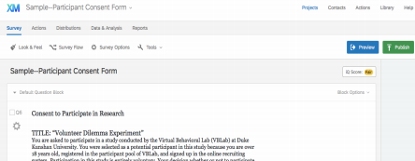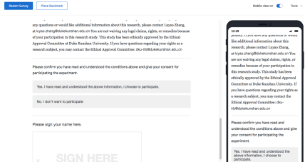

At the end of the day, click on “publish”. Then you can share the link to your subjects! 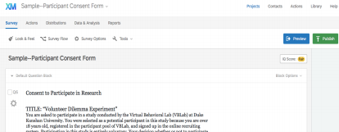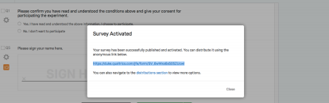

https://duke.qualtrics.com/jfe/form/SV_6wWxx6s505ZUcwl